**SQL CODES**

**Creation of Master table**

create view brand1 as

select * from audi

union

select * from bmw

union

select * from hyndai

union

select * from merc

union

select * from cclass1;

select * from brand1;

create view master_table1 as

select A.id,A.model_id, A.year,A.price,A.mileage,A.tax,A.mpg,A.enginesize,A.car_name,A.transmission_id,A.fuel_id,B.model_name,C.fueltype,D.transmission

from brand1 A left join models B

on A.model_ID = B.model_ID left join fueltype C

on A.fuel_ID = C.fuel_id left join transmission D

on A.transmission_ID = D.ID;

select * from master_table1

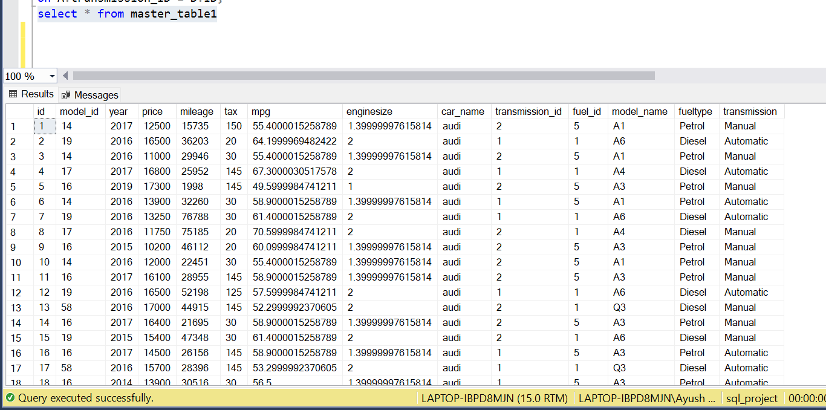

Q.1 a.  Create an analysis to find income class of UK citizens based on price of Cars(You can use per-capita income in UK from internet sources)

use sql_project

select A.model_id, A.model_name, A.price,B.per_capita_income,A.car_name ,B.year,abs((A.price)*100/per_capita_income) as perc

from master_table1 as A

inner join [dbo].[per capita income] as B on A.year=B.year

where A.year > 2018

order by A.year desc;

-----------------------------------------------------------------------------------

create view view_brand1 as

select A.model_id, A.model_name, A.price,B.per_capita_income,A.car_name ,B.year,abs((A.price)*100/per_capita_income) as perc

from master_table1 as A

inner join [dbo].[per capita income] as B on A.year=B.year

where A.year > 2018;

select * from view_brand1;

------------------------------------------------------------------------------------

select *, case when perc >= 130 then 'Rich'

when perc >= 70 then 'Middle_class'

when perc >= 0 then 'Poor' end as class_of_customer

from view_brand1

order by year desc;

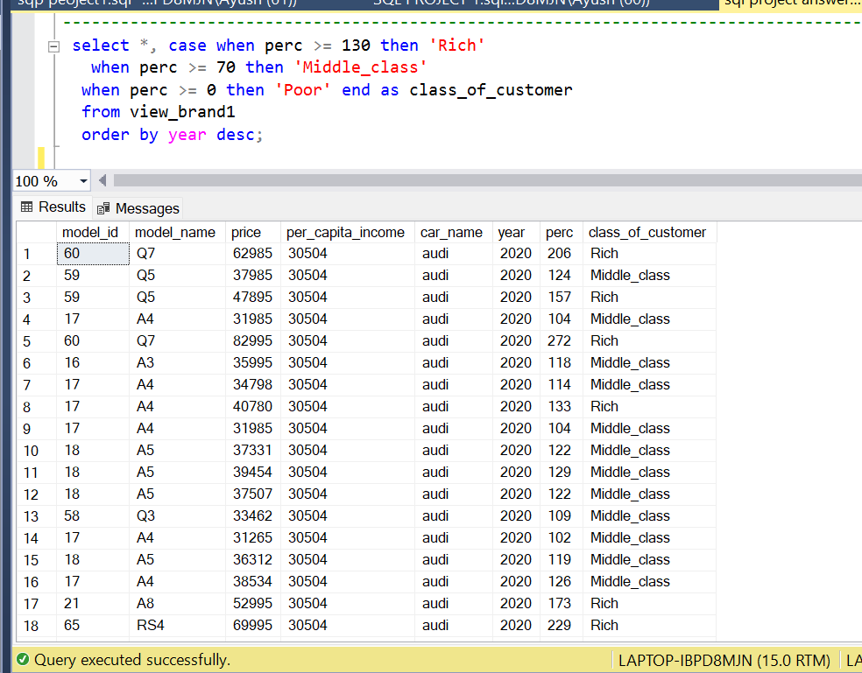

---Q2.a. price changes across the years and identify the categories which has seen significant jump in its price

-----------------------------------------------------------------------------------------------

create VIEW audie as

SELECT b.id,b.year, b.model_id ,a.model_name,b.price FROM models as a inner join audi as b on a.model_ID = b.model_ID

create VIEW audie2 as

SELECT avg(price) as avg_price ,year,model_name from audie where year > 2016 GROUP BY model_name,year

SELECT model_name,[2016],[2017],[2018],[2019],[2020],

([2017]-[2016]) as jump_1,([2018]-[2017]) as jump_2,([2019]-[2018]) as jump_3,([2020]-[2019]) as jump_4

FROM audie2

pivot (avg(avg_price) for year in ([2016],[2017],[2018],[2019],[2020]))as a

--------------------------------------------------------------------------------------------------------

create VIEW bmwe as

SELECT b.id,b.year, b.model_id ,a.model_name,b.price FROM models as a inner join bmw as b on a.model_ID = b.model_ID

create VIEW bmwe1 as

SELECT avg(price) as avg_price ,year,model_name from bmwe GROUP BY model_name,year

SELECT model_name,[2016],[2017],[2018],[2019],[2020],

([2017]-[2016]) as jump_1,([2018]-[2017]) as jump_2,([2019]-[2018]) as jump_3,([2020]-[2019]) as jump_4

FROM bmwe1

pivot (avg(avg_price) for year in ([2016],[2017],[2018],[2019],[2020]))as a

-----------------------------------------------------------------------------------------------------------------------

create VIEW cclasse as

SELECT b.id,b.year, b.model_id ,a.model_name,b.price FROM models as a inner join cclass as b on a.model_ID = b.model_ID

create VIEW cclasse1 as

SELECT avg(price) as avg_price ,year,model_name from cclasse GROUP BY model_name,year

SELECT model_name,[2016],[2017],[2018],[2019],[2020],

([2017]-[2016]) as jump_1,([2018]-[2017]) as jump_2,([2019]-[2018]) as jump_3,([2020]-[2019]) as jump_4

FROM cclasse1

pivot (avg(avg_price) for year in ([2016],[2017],[2018],[2019],[2020]))as a

------------------------------------------------------------------------------------------------------------------------------------

create VIEW hyndaie as

SELECT b.id,b.year, b.model_id ,a.model_name,b.price FROM models as a inner join hyndai as b on a.model_ID = b.model_ID

create VIEW hyndaie1 as

SELECT avg(price) as avg_price ,year,model_name from hyndaie GROUP BY model_name,year

SELECT model_name,[2016],[2017],[2018],[2019],[2020],

([2017]-[2016]) as jump_1,([2018]-[2017]) as jump_2,([2019]-[2018]) as jump_3,([2020]-[2019]) as jump_4

FROM hyndaie1

pivot (avg(avg_price) for year in ([2016],[2017],[2018],[2019],[2020]))as a

-----------------------------------------------------------------------------------------------------------------------------------------

create VIEW merce as

SELECT b.id,b.year, b.model_id ,a.model_name,b.price FROM models as a inner join merc as b on a.model_ID = b.model_ID

create VIEW merce1 as

SELECT avg(price) as avg_price ,year,model_name from merce GROUP BY model_name,year

SELECT model_name,[2016],[2017],[2018],[2019],[2020],

([2017]-[2016]) as jump_1,([2018]-[2017]) as jump_2,([2019]-[2018]) as jump_3,([2020]-[2019]) as jump_4

FROM merce1

pivot (avg(avg_price) for year in ([2016],[2017],[2018],[2019],[2020]))as a

--A part -

create VIEW pricee as

SELECT id,year, model_id ,model_name,price,car_name FROM master_table1 WHERE year > 2017

create VIEW pricee1 as

SELECT avg(price) as avg_price ,year,model_name, car_name from pricee GROUP BY model_name,year,car_name

ORDER by year

SELECT car_name, model_name,[2018],[2019],[2020],

([2019]-[2018]) as jump_1,([2020]-[2019]) as jump_2

FROM pricee1

pivot (avg(avg_price) for year in ([2018],[2019],[2020]))as a

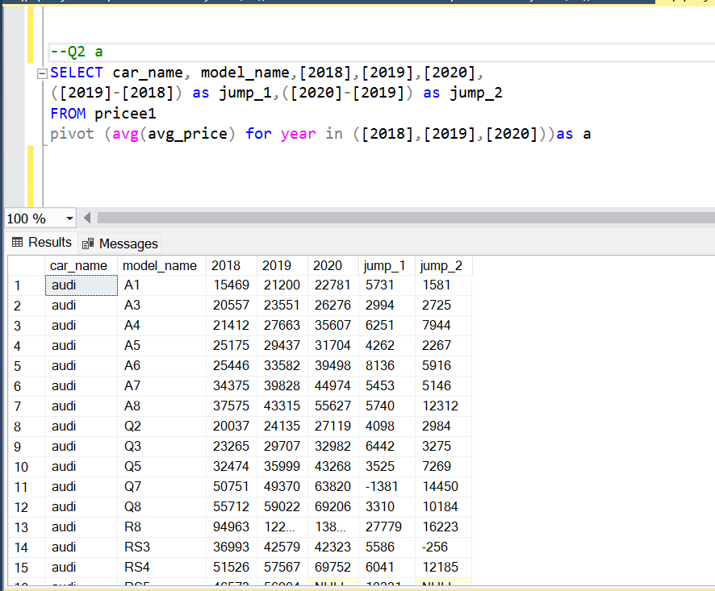

----Q2.b. changes in no of cars sold across the years and identify the categories which has seen significant jump in its sale

--------------------------------------------------------------------------------------------------------------------------------------------

CREATE VIEW audiee as

SELECT b.year, count(b.model_id) as mod ,a.model_name,b.price FROM models as a inner join audi as b on a.model_ID = b.model_ID

GROUP by b.year,a.model_name,b.price

CREATE VIEW audiee1 as

SELECT year,sum(mod) as b,model_name FROM audiee GROUP by year,model_name ORDER by year

SELECT model_name,[2016],[2017],[2018],[2019],[2020],

([2017]-[2016]) as jump_1,([2018]-[2017]) as jump_2,([2019]-[2018]) as jump_3,([2020]-[2019]) as jump_4

FROM audiee1

pivot(avg(b) FOR year in ([2016],[2017],[2018],[2019],[2020])) as a

-----------------------------------------------------------------------------------------------------------------------------------------------------------

CREATE VIEW bmwee as

SELECT b.year, count(b.model_id) as mod ,a.model_name,b.price FROM models as a inner join bmw as b on a.model_ID = b.model_ID

GROUP by b.year,a.model_name,b.price

CREATE VIEW bmwee1 as

SELECT year,sum(mod) as count_sales,model_name FROM bmwee GROUP by year,model_name ORDER by year

SELECT model_name,[2016],[2017],[2018],[2019],[2020],

([2017]-[2016]) as jump_1,([2018]-[2017]) as jump_2,([2019]-[2018]) as jump_3,([2020]-[2019]) as jump_4

FROM bmwee1

pivot(avg(count_sales) FOR year in ([2016],[2017],[2018],[2019],[2020])) as a

--------------------------------------------------------------------------------------------------------------------------------------------------------

CREATE VIEW cclassee as

SELECT b.year, count(b.model_id) as mod ,a.model_name,b.price FROM models as a inner join cclass as b on a.model_ID = b.model_ID

GROUP by b.year,a.model_name,b.price

CREATE VIEW cclassee1 as

SELECT year,sum(mod) as count_sales,model_name FROM cclassee GROUP by year,model_name ORDER by year

SELECT model_name,[2016],[2017],[2018],[2019],[2020],

([2017]-[2016]) as jump_1,([2018]-[2017]) as jump_2,([2019]-[2018]) as jump_3,([2020]-[2019]) as jump_4

FROM cclassee1

pivot(avg(count_sales) FOR year in ([2016],[2017],[2018],[2019],[2020])) as a

----------------------------------------------------------------------------------------------------------------------------------------------------------

CREATE VIEW hyndaiee as

SELECT b.year, count(b.model_id) as mod ,a.model_name,b.price FROM models as a inner join hyndai as b on a.model_ID = b.model_ID

GROUP by b.year,a.model_name,b.price

CREATE VIEW hyndaiee1 as

SELECT year,sum(mod) as count_sales,model_name FROM hyndaiee GROUP by year,model_name ORDER by year

SELECT model_name,[2016],[2017],[2018],[2019],[2020],

([2017]-[2016]) as jump_1,([2018]-[2017]) as jump_2,([2019]-[2018]) as jump_3,([2020]-[2019]) as jump_4

FROM hyndaiee1

pivot(avg(count_sales) FOR year in ([2016],[2017],[2018],[2019],[2020])) as a

-----------------------------------------------------------------------------------------------------------------------------------------------------------

CREATE VIEW mercee as

SELECT b.year, count(b.model_id) as mod ,a.model_name,b.price FROM models as a inner join merc as b on a.model_ID = b.model_ID

GROUP by b.year,a.model_name,b.price

CREATE VIEW mercee1 as

SELECT year,sum(mod) as count_sales,model_name FROM mercee GROUP by year,model_name ORDER by year

SELECT model_name,[2016],[2017],[2018],[2019],[2020],

([2017]-[2016]) as jump_1,([2018]-[2017]) as jump_2,([2019]-[2018]) as jump_3,([2020]-[2019]) as jump_4

FROM mercee1

pivot(avg(count_sales) FOR year in ([2016],[2017],[2018],[2019],[2020])) as a

--b part

create VIEW car_sale_diff as

SELECT year, count(model_id) as mod ,model_name, price,car_name FROM master_table1 where year>'2017' group by

car_name, year,model_name,price

create view car_sale_diff1 as

SELECT year,sum(mod) as sale_car,model_name,car_name FROM car_sale_diff

GROUP by year,model_name,car_name

ORDER by year

SELECT car_name, model_name,[2018],[2019],[2020],

([2019]-[2018]) as jump_1,([2020]-[2019]) as jump_2

FROM car_sale_diff1

pivot(avg(sale_car) FOR year in ([2018],[2019],[2020])) as a

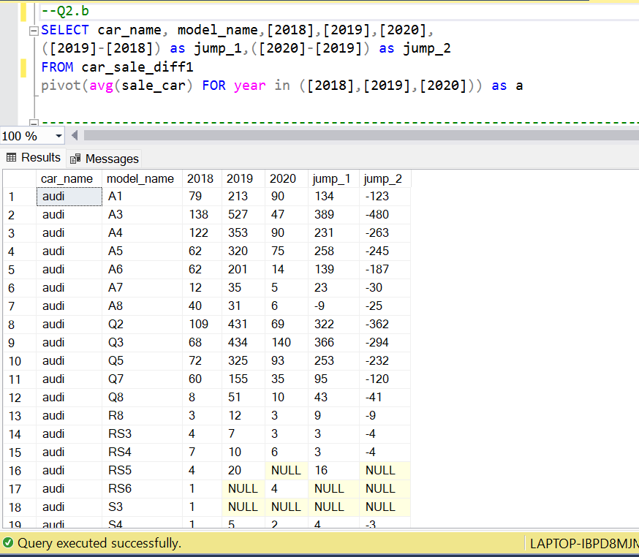

--C . Find relationship between fuel efficiency & price of car/sales of car/fuel type/, etc.

use sql_project

select * into #recent from master_table1

where year >'2016';

select * from #recent;

select * from master_table1;

select max(mileage) from #recent

select min(mileage) from #recent

select max(price) from #recent

select min(Price) from #recent

select model_id,mileage,price, DENSE_RANK()over( order by mileage) from #recent

where car_name = 'merc';

select count(id) from #recent

where car_name = 'bmw' and fueltype = 'petrol';

select count(id) from #recent

where car_name = 'bmw' and fueltype = 'diesel';

select *,count(id) over(partition by fueltype order by mileage desc) from #recent

where car_name = 'merc' and fueltype = 'petrol';

select * ,count(id) over(partition by fueltype order by mileage desc) from #recent

where car_name = 'merc' and fueltype = 'diesel';

select model_id,mileage,price, DENSE_RANK()over( order by mileage desc) from #recent

where car_name = 'merc';

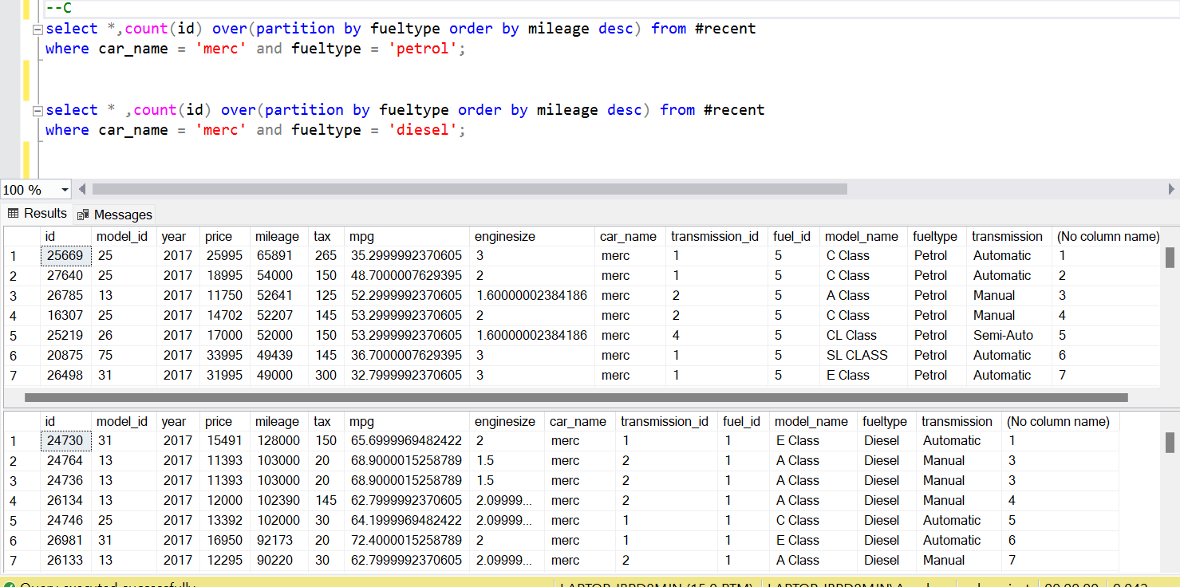

--Q.4 You are also asked to rank across all the models based on their total sales, average price, average mileage, average engine size, etc.

--and now filter the top 5 basis their sales. Observe the identified models and provide your inference.

--avg price

create proc avg_price @car_name varchar(50) as begin

select top 5 year,model_name,car_name,avg(price)as avg_price,DENSE_RANK()over(order by avg(price)desc)from master_table1

where year >2016 and car_name =@car_name

group by year,model_name,car_name

end;

exec avg_price merc;

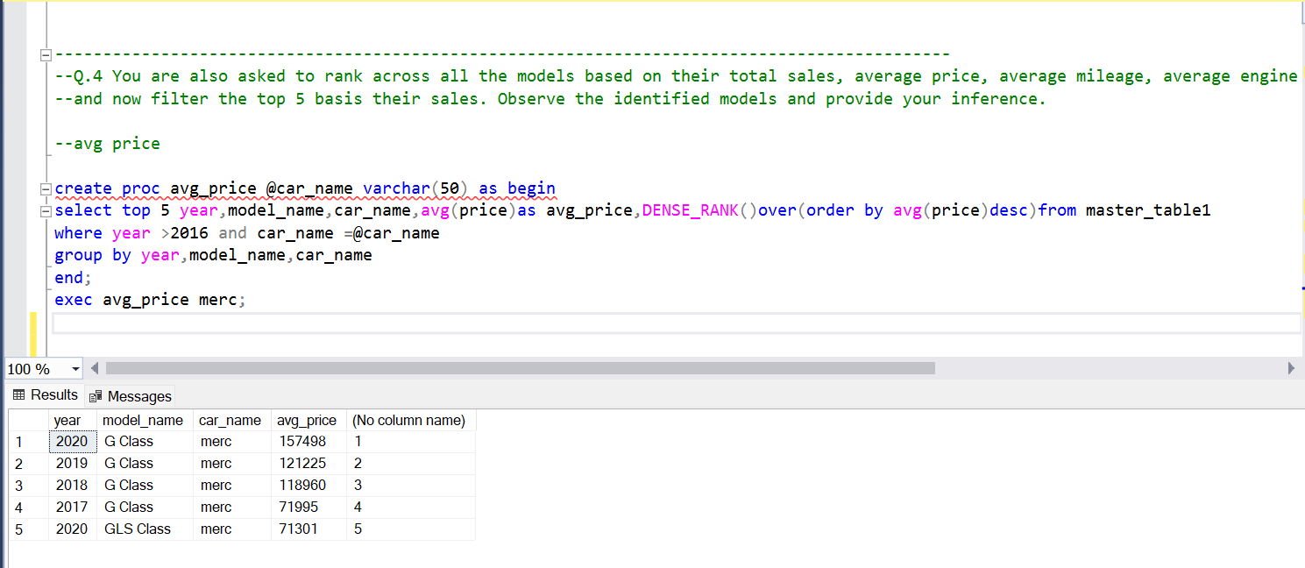

--total sales

ALTER proc total_sales @car_name varchar(50) as begin

select top 5 year,model_name,car_name,count(model_id)as total_sales ,DENSE_RANK()over(order by count(model_id)desc) as rank

from master_table1

where year >2016 and car_name =@car_name

group by year,model_name,car_name

end;

exec total_sales merc;

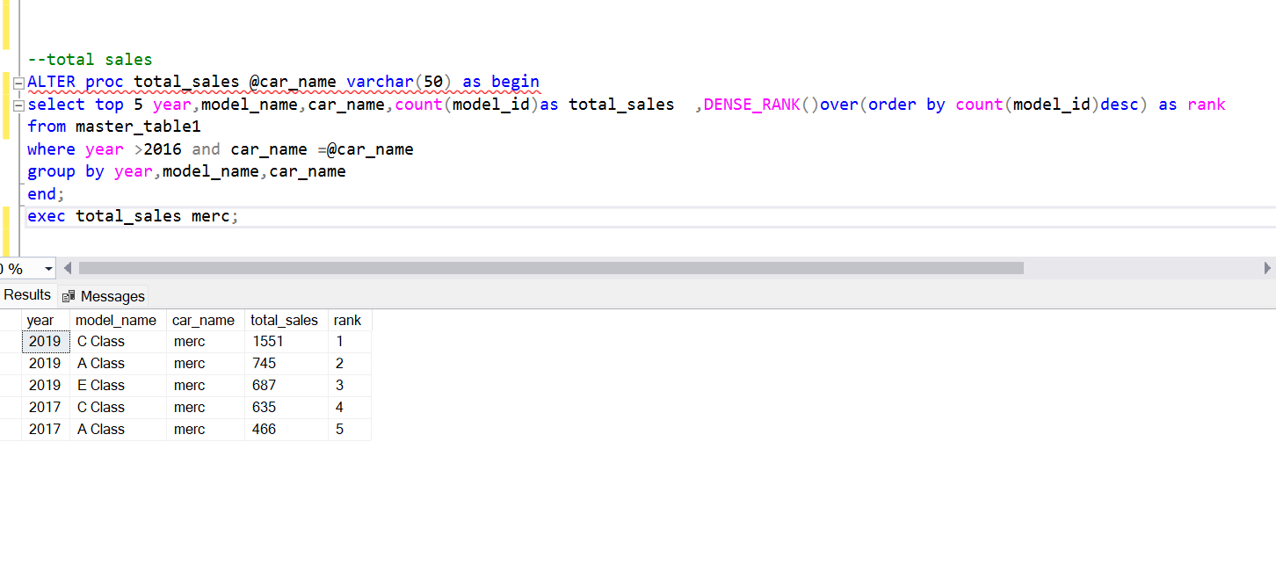

----avg_mileage

create proc avg_mileage @car_name varchar(50) as begin

select top 5 year,model_name,car_name,avg(mileage)as avg_mileage ,DENSE_RANK()over(order by avg(mileage)) as rank from master_table1

where year >2016 and car_name =@car_name

group by year,model_name,car_name

end;

exec avg_mileage merc;

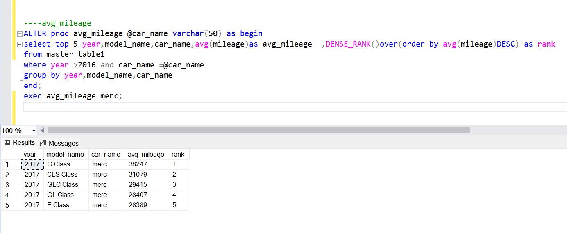

--avg engine size

create proc engine_size @car_name varchar(50) as begin

select top 5 year,model_name,car_name,avg(enginesize)as engine_size ,DENSE_RANK()over(order by avg(enginesize) desc) as rank

from master_table1

where year >2016 and car_name =@car_name

group by year,model_name,car_name

end;

exec engine_size merc;

